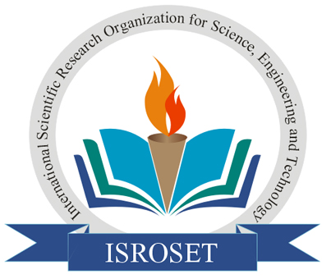 | World Academics Journal of  Enginering Sciences  An International Peer-Reviewed Academic Research Journal | 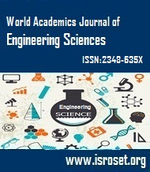

Copyright Transfer Form
To,
The Editor-in-chief
WAJES (ISSN-2348-635X), India
Corresponding Author Name: ……………………………………..Manuscript/Paper ID: …...…………………….
Title of Manuscript: ……………………………..…………………...……………………………………………….
…………………………….………………………………..…………………………………………………………
Category: Research Paper[ ], Review Paper [ ], Survey Paper [ ], Other [ ]
Author(s) Name(s): ….…………….………………………………...…………………………………….…………
……………………………………………………………………………….………………..………………………
Authors Email ID: ……………………………………………………………………………………………………
…………………………….…………………………………………………………………….…………………….
Name of Institute /Organization(s): ………………..……………………………………………………………..….
…………………………….…………………………………………………………………………………………..
Corresponding author (Email ID): .. ……………………...………...………………….……………………….……

License Agreement
For the submission of a manuscript (mention paper type here):
I hereby declare, on behalf of myself and my co-authors (if any), that:
- The manuscript submitted is an original work and has neither been published in any other peer reviewed journal nor is under consideration for publication by any other journal. More so, the manuscript does not contravene any existing copyright or any other third party rights.
- I am/we are the sole author(s) of the manuscript and maintain the authority to enter into this agreement and the granting of rights to WAJES does not infringe any clause of this agreement.
- The manuscript contains no such material that may be unlawful, defamatory, or which would, if published, in any way whatsoever, violate the terms and conditions as laid down in the agreement.
- I/we have taken due care that the scientific knowledge and all other statements contained in the manuscript conform to true facts and authentic formulae and will not, if followed precisely, be detrimental to the user.
- I/we permit the adaptation, preparation of derivative works, oral presentation or distribution, along with the commercial application of the work.
- No responsibility is assumed by WAJES, its staff or members of the editorial board for any injury and/or damage to persons or property as a matter of products liability, negligence or otherwise, or from any use or operation of any methods, products instruction, advertisements or ideas contained in a publication by WAJES.

Copyright Transfer
Copyright to the above work (including without limitation, the right to publish the work in whole, or in part, in any and all forms) is hereby transferred to WAJES, to ensure widest dissemination and protection against infringement. No proprietary right other than copyright is proclaimed by WAJES.

Under the Following Conditions: Attribution
- The services of the original author must be acknowledged;
- In case of reuse or distribution, the license conditions must be clarified to the user of this work;
- Any of these conditions can be ignored on the consent of the author.

Sign Here For Copyright Transfer: I/We hereby certify that I/We am authorized to sign this document either in my own right or as an agent of my employer, and have made no changes to the current valid document supplied by WAJES.

Author's Signature & Date [Corresponding Author (in case many authors)] …………………..…….……...………………...…...

Typed or Printed Name: .……..…….…...……………………………………………….. Send either to: isroset@gmail.com

